COBOL tutorial for beginners - https://www.youtube.com/watch?v=_pAX_ogguLI&t=5448s
Variable Naming Standard
* The name can only contain letters, numbers and a hyphen
* A programmer-supplied name has a max of 30 characters
* Data names must contain at least one letter
* Paragraph names may be all numeric

Defining Variables

05 WS-EAST PIC 9(7) VALUE ZEROES.

05 – Level Number
WS-EAST – Data name
PIC 9(7) – Picture clause
VALUE ZEROES – Value clause (optional)

Level Numbers
Level | Use
01 | Field description or group-level items
02-49 | Elementary items
66 | Reserved for the rename clause
77 | Items that cannot be subdivided
88 | Condition name entries

Comp-3 Data Types
* Comp-3 is considered a packed decimal
* Each byte of storage can contain two decimal values
* Here is an example representing the decimal number 21544

Byte 1 | Byte 2 | Byte 3
2. 1 | 5. 4 | 4 sign
0010 | 0001 | 0101 | 0100 | 0100 | 1111

* Numeric fields are reduced to half their original size
* Memory and disk space were vital and expensive
* Using Comp-3 performs arithmetic computations differently

Numeric Literals
* A numeric literal can be up to 18 digits long
* A numeric literal may begin with a plus or minus sign
* A numeric literal may contain a decimal point

Non-Numeric Literals
* A non-numeric literal is enclosed in apostrophes
* A non-numeric literal may not contain an apostrophe

Figurative Constants
* HIGH-VALUES, LOW-VALUES
* ZERO/ZEROES
* SPACES
* QUOTES

Editing Characters

Character | Meaning | Character | Meaning
Z | Zero suppression | B | Blank
$ | Floating dollar sign | CR | Credit
, | Comma | DB | Debit
* | Check protection | + | Plus sign
0 | Zero | - | Minus sign

Computational Verbs

ADD
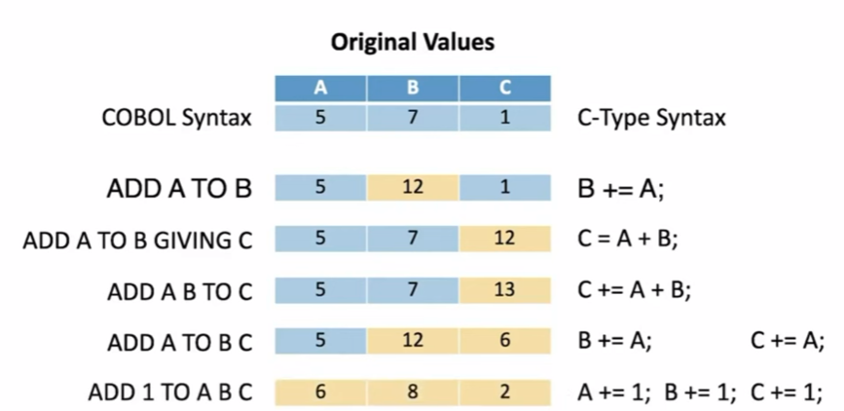

DIVIDE
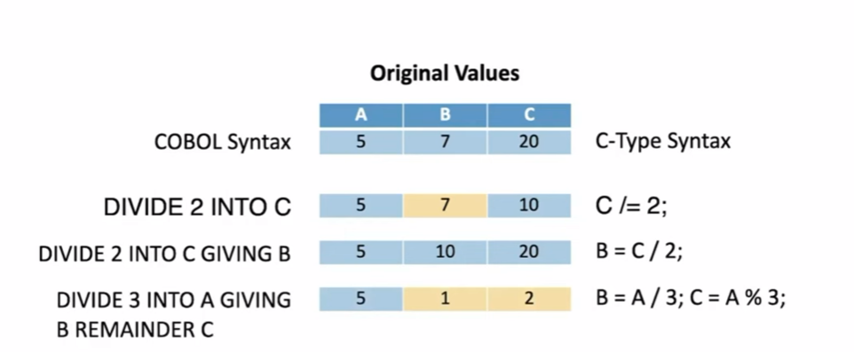
Conditional Expressions

* IF condition, execute statement(s)
* IF...ELSE...
* IF...ELSE...END-IF
* Nested IF statements are allowed

* IS NUMERIC
* IS ALPHABETIC, IS ALPHABETIC-UPPER, IS ALPHABETIC-LOWER
* IS POSITIVE, IS NEGATIVE
* AND, OR, NOT

* IS GREATER THAN (>), IS LESS THAN (<)
* IS EQUAL TO (=)
* IS NOT
* IS GREATER THAN OR EQUAL TO (>=)
* IS LESS THAN OR EQUAL TO (<=)

* EVALUATE...END-EVALUATE
EVALUATE TRUE
WHEN REGION = ‘EAST’
ADD YEARLYSALES TO EAST-TOTAL
...
WHEN OTHER...
END-EVALUATE

Creating a Sales Report

petstorechallenge.cbl 1:30

